Name :-Kunal R Agarwal

SRN No:-201700110

Roll No:-18

Question:-**Implement candidate elimination algorithm on given data set.**

**Input:-**

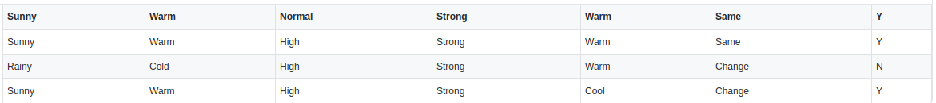

**Code:-**

import numpy as np

import pandas as pd

import os

data=pd.read_csv("../input/candielimination/CandidateElimination.csv")

concepts = np.array(data.iloc[:,0:-1])

target = np.array(data.iloc[:,-1])

def learn(concepts, target):

specific_h = concepts[0].copy()

print("Initialization of specific_h and general_h")

print("specific_h: ",specific_h)

general_h = [["?" for i in range(len(specific_h))] for i in range(len(specific_h))]

print("general_h: ",general_h)

print("concepts: ",concepts)

for i, h in enumerate(concepts):

if target[i] == "Y":

for x in range(len(specific_h)):

#print("h[x]",h[x])

if h[x] != specific_h[x]:

specific_h[x] = '?'

general_h[x][x] = '?'

if target[i] == "N":

for x in range(len(specific_h)):

if h[x] != specific_h[x]:

general_h[x][x] = specific_h[x]

else:

general_h[x][x] = '?'

print("\nSteps of Candidate Elimination Algorithm: ",i+1)

print("Specific_h: ",i+1)

print(specific_h,"\n")

print("general_h :", i+1)

print(general_h)

indices = [i for i, val in enumerate(general_h) if val == ['?', '?', '?', '?', '?', '?']]

print("\nIndices",indices)

for i in indices:

general_h.remove(['?', '?', '?', '?', '?', '?'])

return specific_h, general_h

s_final,g_final = learn(concepts, target)

print("\nFinal Specific_h:", s_final, sep="\n")

print("Final General_h:", g_final, sep="\n")

**Output:-**

